

**Travel Agency Website**

Senior Project

By

**Houssam Bikai and Anas Sharaf**

Submitted to the School of Arts & Science of the

Lebanese International University Saida, Lebanon

In part of fulfillment of the requirements for the degree of

**BACHERLOR OF SCIENCE IN**

**COMPUTER SCIENCE AND INFORMATION TECHNOLOGY**

**Supervised by: Dr. Rabia Amro**

Spring 2022

Abstract

# Most people in this world like to travel from one place to another no matter

# Whether it is a small or large distance. This project “Travel around the World” is

# Used to automate all process of the travel and tourism, which deals with creation,

# Booking and confirmation and user details. The project is designed HTML-PHP as

# Front end and Microsoft SQL Server as Backend which works in any browsers.

# The coding language used HTML, PHP, JSON, BOOTSTRAP, and CSS. Travel

# Around the World is used to Book a tour from anywhere in the world by a Single

# Dynamic website which will help the user to know all about the places and Tour

# Details in a single website, so that customer can easily book ticket for all packages

# Of tourist place such as hills, Trekking, adventures, spirituals and etc. Details of

# Different types of tours which Include tours like family tours, couple tours,

# Religious tours, safari, camping, hiking, diving and skydiving tours. Through this

# Site we can this site gives new Packages on flexible price, so that user can book

# Easily. According to season The Admin can add, change, update, and delete

# Packages to the website from a certain Travel agents. He also can view booking

# And can add, change, update, and delete Categories and sub-categories. Then the

# Users can sign in and book each package, which can be easily booked and know the all details.

**INTRODUCTION**

Travel around the World is used to book a tour from anywhere in the

World by a Single dynamic website which will help the user to know all

About the places and Tour details in a single website. The admin can

Add packages to the website from a certain travel agents. Then the users

Can sign in and book each project, they can be confirmed by the admin

In manage booking page. The user can see the Confirmation in their

Booking page. It is an easiest platform for all travelers which can be

Easily booked and know the all details. Travel around the Worldis a

Dynamic website for tourism business. It is dynamic and responsive web

Design. It is also called travel technology solution for agencies & tour

Operation. Nearly everyone goes on a vacation would play a vital role in

Planning the perfect trip. The Travel around the World system allows

The user of the system access all the Details such as location, events,

Etc. The main purpose is to help tourism Companies to manage

Customer Etc. The system can also be used for Family trips, Business,

And adventures.

**Project overview**

First sign in/sign up weather and admin or user, costumer must register by entering username, email, and password. The first page displays the tittle of our company and navigation bar linked with all the pages and slider which show some pictures of our tours. In the middle we have the most popular destinations and under it we present our services when the costumer press on any service it will inform him where we can travel to apply this services, at the end a footer. Second page is the about is talking about the reason why choose us and you can contact us form the same page by entering your information and leave your comment. Third page you can choose you category with the price. When the customer presses the book he/she will be able to book by entering the username and the package name and choose your date then submit then the admin will approved your request then you can logout.

**Objective**

The main objective of the Project on Travel around the World is to manage the details

Of Travel, Tour, Agent, and Facility. It manages all the information about Travel,

Customer, Facility, Travel. The project is totally built at administrative end and thus only

The administrator is guaranteed the access. The purpose of the project is to build an

Website to reduce the manual work for managing the Travel, Tour,

Customer, Agent. It tracks all the details about the Agent and Facility.

**Software used**

**-Visual Studio Code**:

In software development, the use of Visual Studio Code can combine the simplicity of a source code editor with powerful developer tooling, like IntelliSense code completion and debugging. First and foremost, it is an editor that gets out of your way. The delightfully friction-less edit-build-debug cycle means less time fiddling with your environment, and more time executing on your ideas. VS Code includes enriched built-in support for Node.js development with JavaScript and Typescript, powered by the same underlying technologies that drive Visual Studio. VS Code also includes great tooling for web technologies such as JSX/React, HTML, CSS, SCSS, Less, and JSON.



**-MySQL:**

Is a relational database management system based on SQL – Structured Query Language the application is used for a wide range of purposes, including data warehousing, e-commerce, and logging applications the most common use for MySQL however, is for the purpose of a web database It can be used to store anything from a single record of information to an entire inventory of available products for an online store

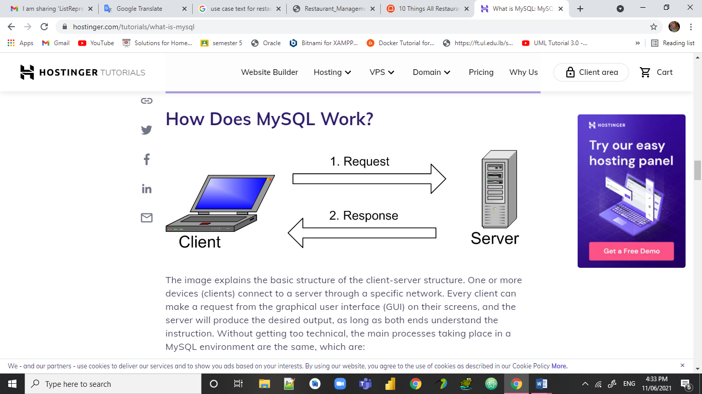

1. MySQL creates a database for storing and manipulating data, defining the relationship of each table.
2. Clients can make requests by typing specific SQL statements on MySQL.
3. The server application will respond with the requested information and it will appear on the clients’ side.

**Functional and nonfunctional Requirements**

1. Login
2. Register
3. Logout
4. Book
5. Send message
6. Explore the packages

Non Functional Requirements:

1. Have a database
2. Security
3. Performance

**Actors of the system**

The whole system is used by 2 users: The user and the Admin.

The user can book a package / trip in this website and contact us, but first he/she need to login using a correct username and password.

The admin can do anything in this website, but first he need to login using a correct username and password. The admin can: add /update / delete / view category, subcategory, and packages also he can view the messages sent by the users in the contact us form. Those will be changed from the database

**Use Cases narrative:**

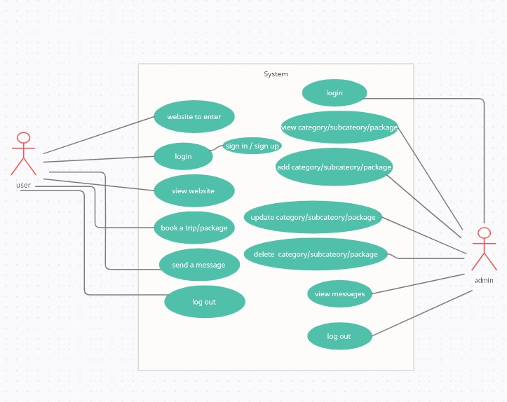

**Use Cases narrative:**

|  |  |  |
| --- | --- | --- |
| **Use case ID** | **Use case** | **Description** |
| 1 | Login | This use case allows the user/ admin to log into the system after they Enter his/her credentials the system will check if he credentials are correct then the system will insert the credentials in the database |
| 2 | Register | This use case allows the user  To create an account in order to login and access the website after they Enter his/her information the system will check if they are correct then the system will insert the credentials in the database |
| 3 | Send a message | This use case allows the user  To send a message to the owners of the website to ask them about something he is not sure about or to send his/her feedback after that the system will insert his message into the data base |
| 4 | Book a package | This use case allow the user to choose one of the packages of the website and choose his/her suitable date to travel after that the system will insert it into the date base |
| 5 | View categories | This use case allow the admin to view the categories that are presented in the website |
| 6 | View subcategories | This use case allow the admin to view the subcategories that are presented in the website |
| **7** | View packages | This use case allow the admin to view the packages that are presented in the website |
| 8 | Add category | C |
| 9 | Add subcategory | This use case allow the admin to add a new subcategory into the website after the admin insert the data in the add subcategory form and the click submit the system will insert the data into the data base |
| 10 | Add package | This use case allow the admin to add a new package into the website after the admin insert the data in the add package form and the click submit the system will insert the data into the data base |
| 11 | Update category | This use case allow the admin to update the category chosen after the admin insert the updated data in the update category form and the click submit the system will update the old data to the new ones in the data base |
| 12 | Update subcategory | This use case allow the admin to update the subcategory chosen after the admin insert the updated data in the update subcategory form and then click submit the system will update the old data to the new ones in the data base |
| 13 | Update package | This use case allow the admin to update the package chosen after the admin insert the updated data in the update package form and the click submit the system will update the old data to the new ones in the data base |
| 14 | Delete category | This use case allow the admin to delete a category from the data base after choosing it from the delete category form and the after clicking submit the system will delete the category chosen from the data base |
| 15 | Delete subcategory | This use case allow the admin to delete a subcategory from the data base after choosing it from the delete subcategory form and the after clicking submit the system will delete the subcategory chosen from the data base |
| 16 | Delete package | This use case allow the admin to delete a package from the data base after choosing it from the delete package form and the after clicking submit the system will delete the package chosen from the data base |
| 17 | View booking | This use case allow the admin to view all the bookings of the user |
| 18 | View messages | This use case allow the admin to view all the messages sent from the user throw contact us form |

**Business process :**

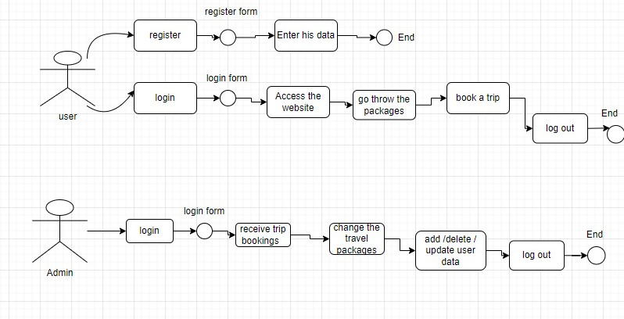

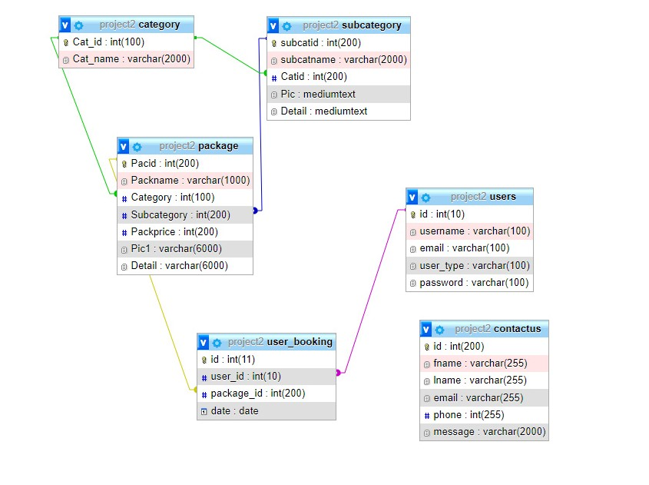UML:

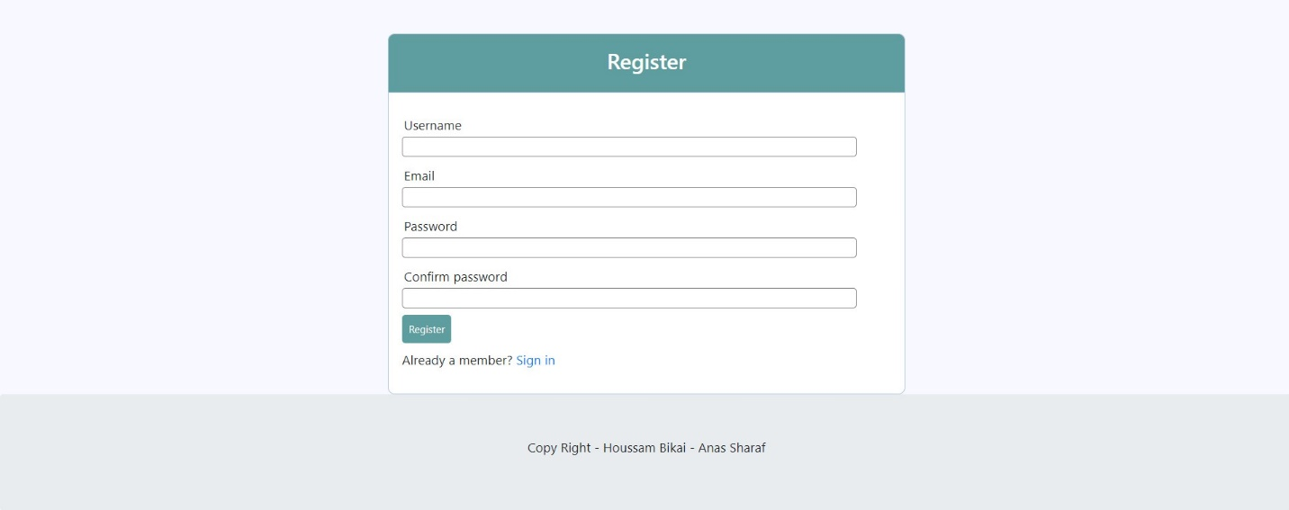Now we will show you the main functionalities of our website alongside with the pages.

First in order to sign in the customer must register. He/she must fill his Username and his/her password then he/she must click on the button register.

Home Page:

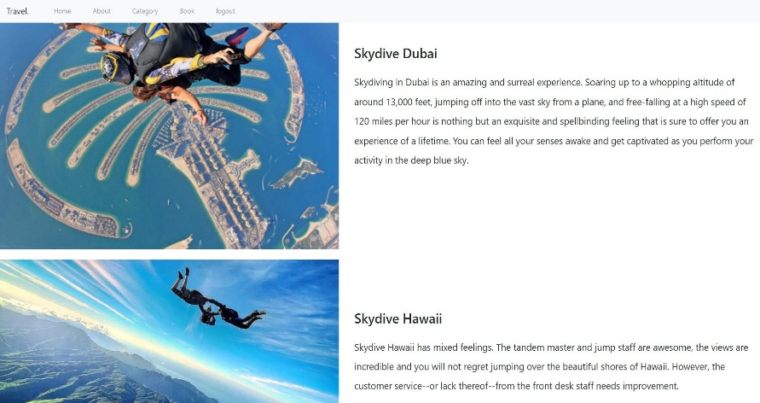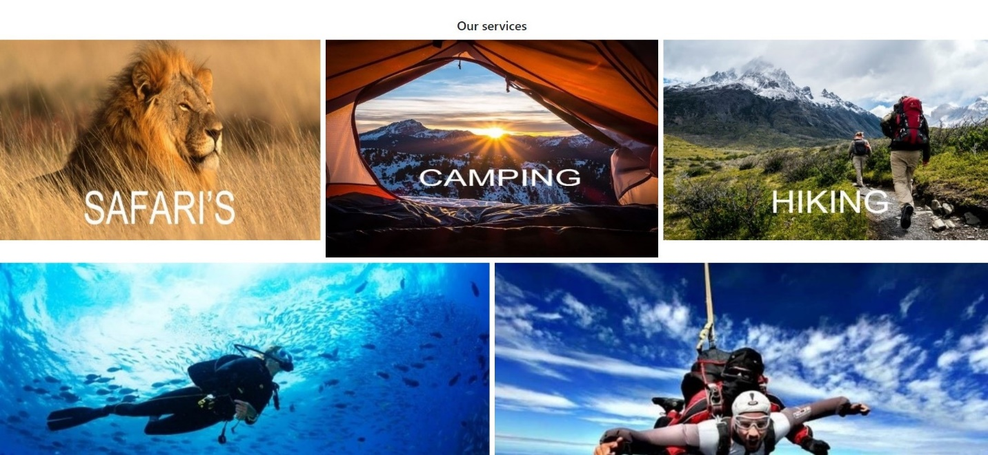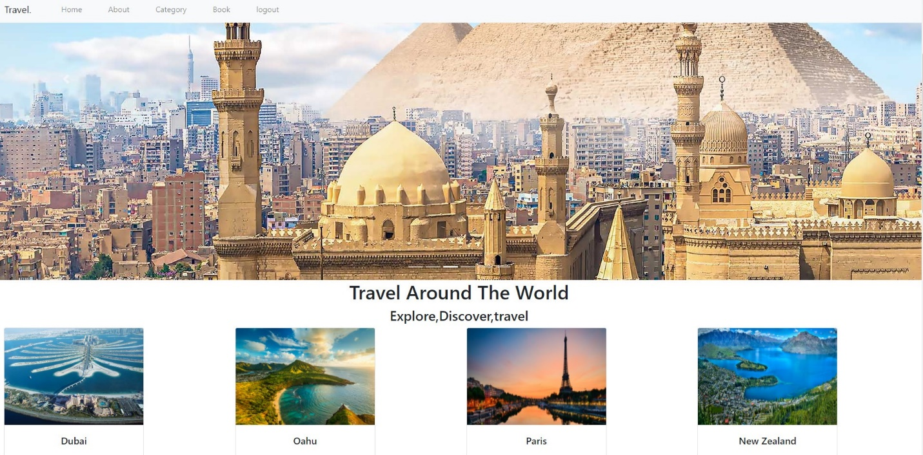

As you can see we have a navy bar a slider which contain some beautiful picture of our tours and then we have the most popular destinations to this year then we list our services when the costumer press on any of them it will inform him where we can travel to apply this services as shown.

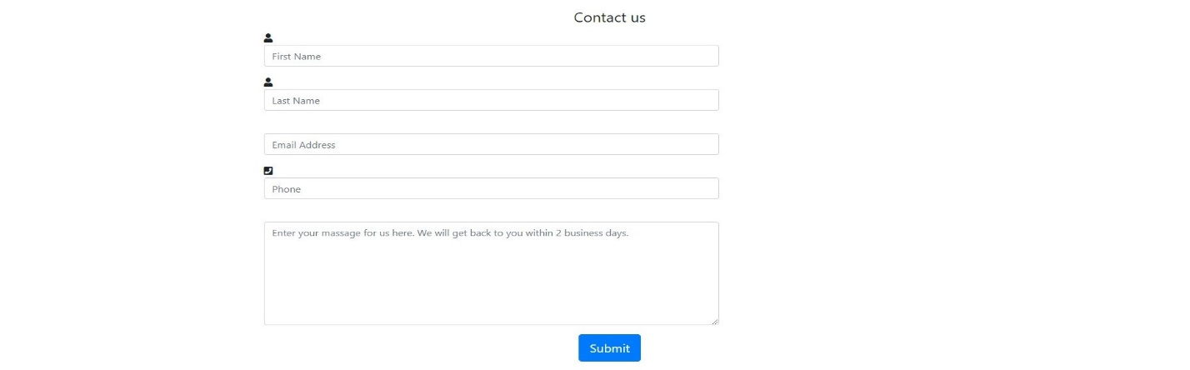**ABOUT PAGE:**

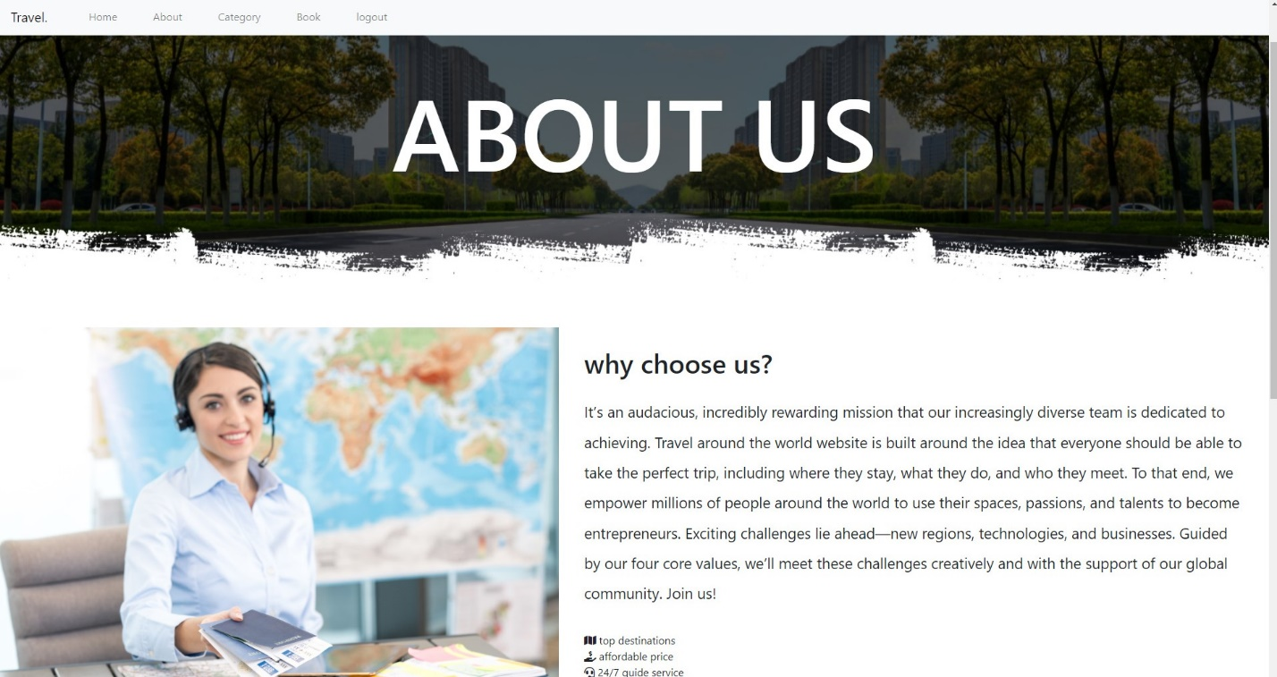 About us: which explains our goal of the website and why choose us.

Contact: which allows the customer to reach us and inquire about any tour.

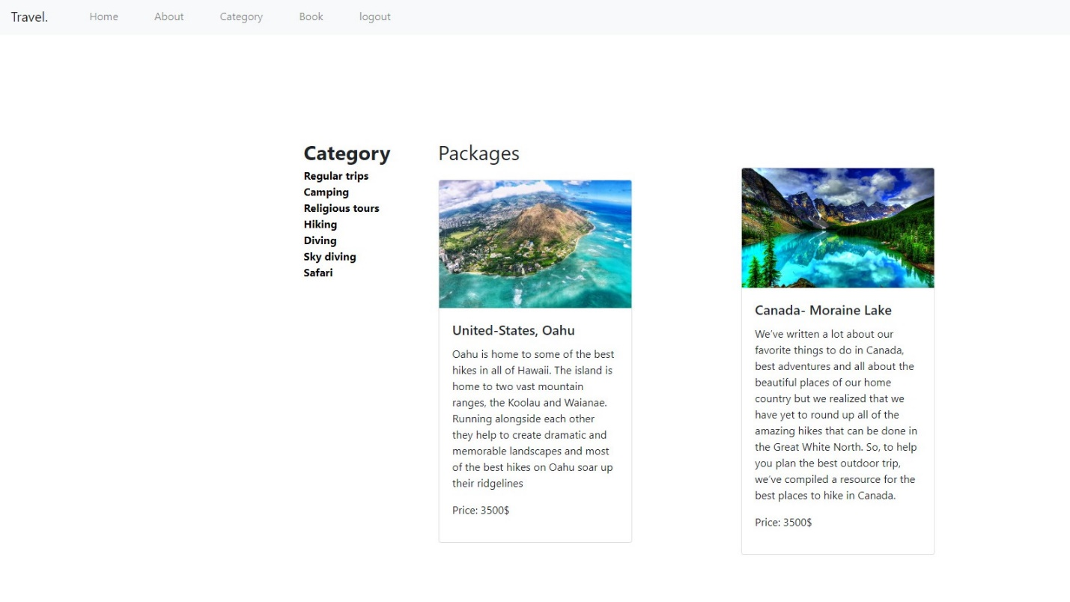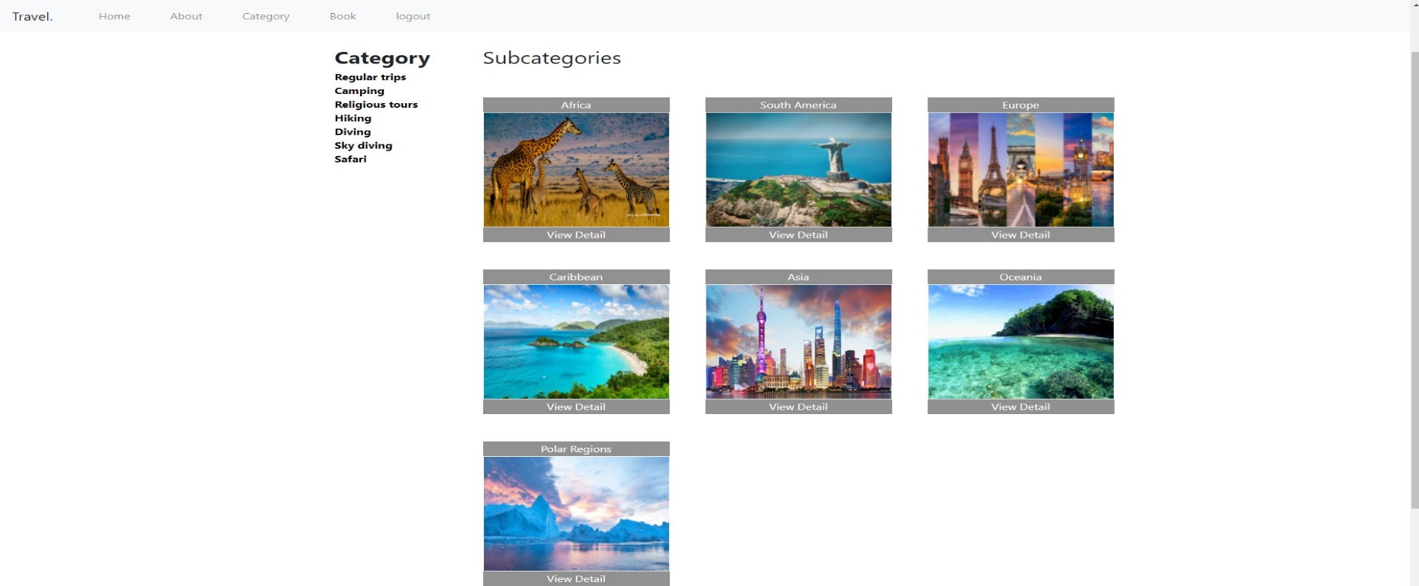**Categories/sub-categories/packages:**

The category page shows the destination of our tours. It contains pictures of destination, the name of every destination, description about it and their price. Our category is designed in special way using css and the items are token from database.

**BOOK:**

Our customer can make a reservation online by clicking on Book, in the navigation bar. He/she must fill the following information of reservation and the today date is displayed by default the date of the day making the online reservation and the price will be selected according to the packaged you have choose , also the name of the user will be written by default in the use name section .

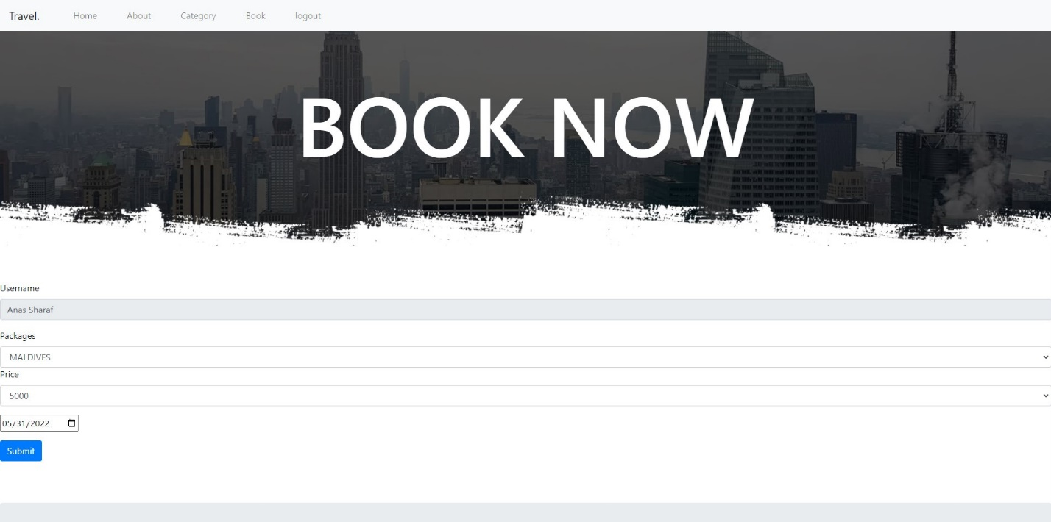

**Admin:**

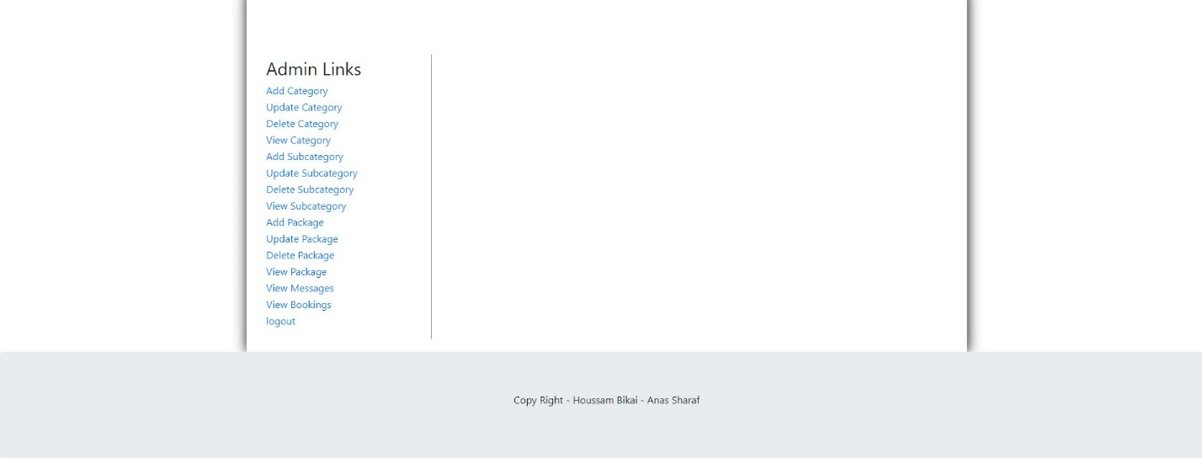The admin can do anything in this website, but first he need to login using a correct username and password. The admin can: add category-update category-delete category-view category-add subcategory-update subcategory- view subcategory-add package- update package- delete package- view package-view message- view booking.

**Database:**

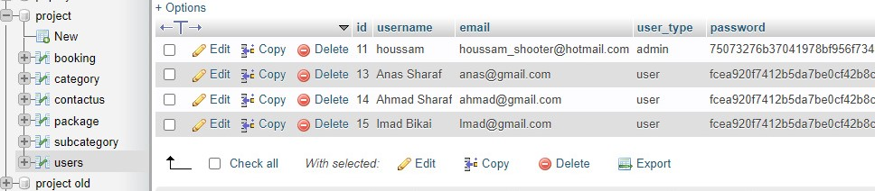**ADMIN and USERS:**

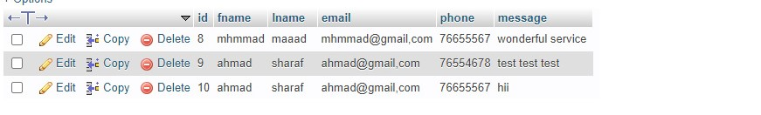**Customers who contact us:**

**Categories**

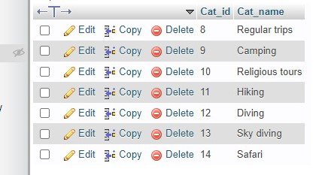

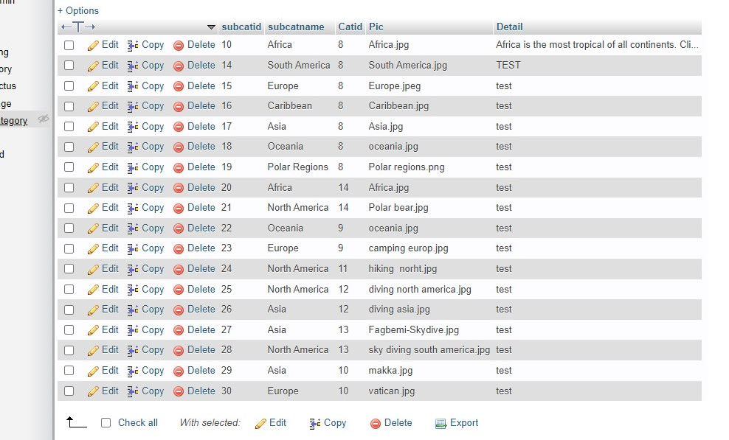**Subcategories:**

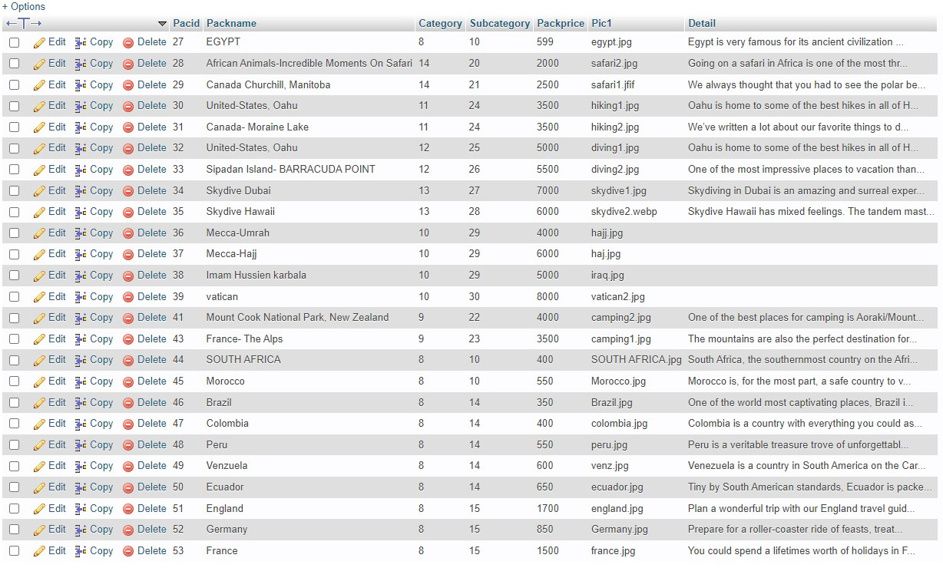**Packages:**

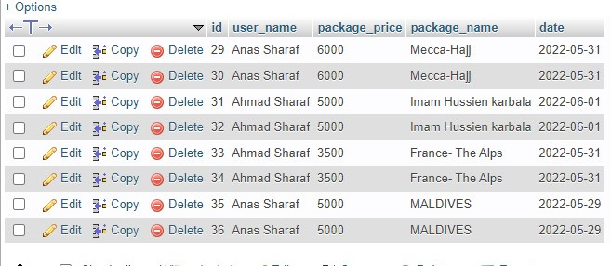**Booking:**